The Images of Women in Helmut Newton’s Photography
I intend to explore Helmut Newton’s work, focusing particularly on his representation of women. Throughout the essay I will identify key stylistic elements of his photography, examining what makes his work distinguishable from other fashion photographers’. Furthermore I will research his influences to give some understanding of what inspired his work. I will also investigate other elements of Newton’s career, including any collaboration with other photographers and designers.
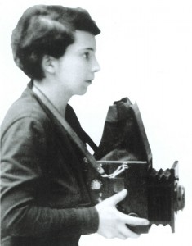
Born in 1920 in Berlin, Newton studied at the American School until he lost interest and left full-time education to attain an apprenticeship with ‘Yva’ (Else Ernestine Neulaender 1900-1944) a renowned fashion photographer. In 1938 due to Hitler’s campaign against their Jewish religion, Newton’s parents fled from Germany to South America and arranged for him to travel to China. Newton travelled on a ship, which stopped at Singapore en route, intrigued he left the ship and found work they’re as a photographer for ‘Straits Times’ newspaper. This career was short lived, after being identified by British authorities as an ‘enemy alien’ in 1940, Newton was deported to Australia where served as an army truck driver until the war drew to an end. Newton then obtained Australian citizenship, changing his original last name ‘Neustadter’ to Newton.
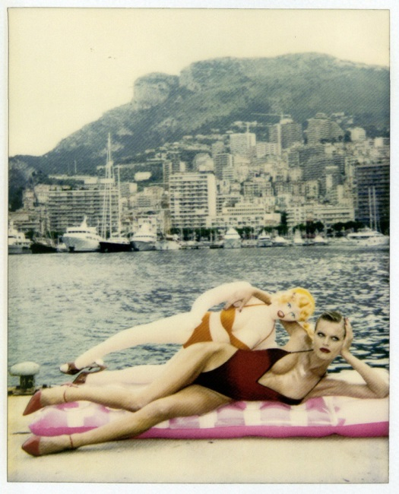
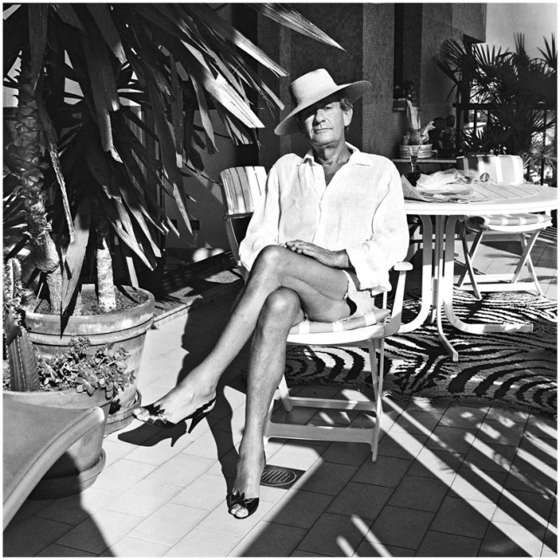
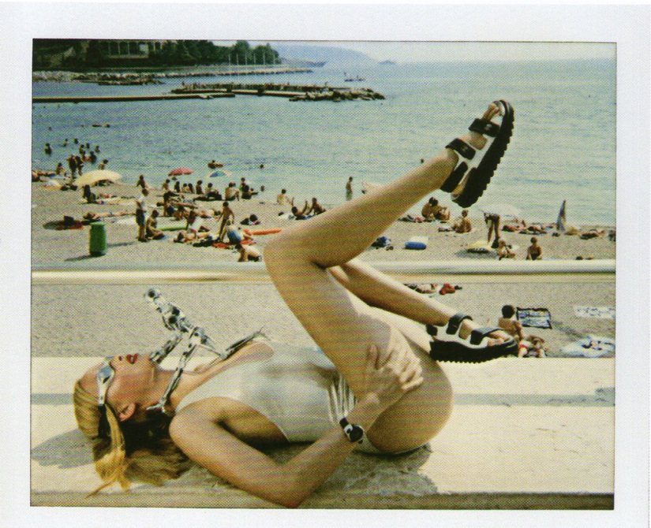
Newton remained in Australia and opened a photography studio on Flanders Lane in the Textile district Melbourne; it was here that he began shooting fashion and theatre photography. In 1953, Newton paired with Henry Talbot to combine their talents, however their partnership was short lived. After being commissioned to shoot for a special supplement of Vogue in 1956, Newton moved to London under a contract with British Vogue, which he didn’t finish before moving to Paris. It was clear that Helmut Newton was never restricted as he shot for a diverse range of fashion magazines and was continually moving between countries. It may’ve been the travel and experiencing different cultures that enriched his photographs with individuality and allowed him to shoot from different perspectives. An environment that greatly contributed to Newton’s work was Monte Carlo, Monaco. The beaches and boardwalks created perfect scenes for his cinematic photography; therefore Monte Carlo became the backdrop of many of his photographs. In an interview with Alain Elkann (1950-present), Newton discussed his decision to move to Monte Carlo after twenty-six years of living in Paris: “I felt the need to make a change. At first I thought about Los Angeles, and then I chose Monte Carlo, and I don’t regret it at all. I have to say that now I do ninety per cent of my photographs here and a part of the printing and archives.” This further expresses the impact Monte Carlo had on his career. On the other hand, Australia seemed to impair the photographer’s ability, he stated “it did not form me as a photographer nor did my work there amount to anything” this may be due to his deportation there and explain why he was eager to travel to different countries.

Helmut Newton is renowned for his voyeuristic, sexual photographs. However, he empowers women through his photography, showing his models as dominant and strong. Whether they are fully clothed or nude, Newton’s female subjects have an overt sex appeal which could be viewed as intimidating, this relates to the feminist ideal of the late nineteenth century ‘The New Woman’ which encouraged women to embrace their sexuality. An image, which embodies this female dominance, is ‘They’re coming!’ (1981), Newton presented it in the style of a diptych. The composition of the models and lighting is identical in each photograph, however in one they are clothed and the other they are nude. Like a majority of his most famous work, this shot is black and white, which removes the distraction of colour and centres the viewers’ attention on composition and tonality. Newton used harsh lighting to create shadows and emphasise the contours of the women’s bodies. Furthermore the neutral background strategically removes other elements, which may distract from the women. Neutral background studio shots were rarely taken by Newton; part of what makes him such an iconic photographer is his elaborate settings. Fashion Photography appeared to be more about society than the clothes to Newton. This idea is implied in his response to studio photography “A woman doesn't live in front of a white-paper background. She lives in a car, in a house, in a street…” Newton seems to desire to take a snapshot of women’s lives. Therefore, the minimalistic background of ‘They’re coming!’ could be to ensure that the piece is less documentary of the times than Newton’s other photographs. The blank setting makes the work timeless and therefore translatable to all generations. Furthermore the women are wearing high-heeled shoes and the photographs have been taken from a slightly low angle which makes the women appear taller and stronger, resulting in a threatening and bold result.
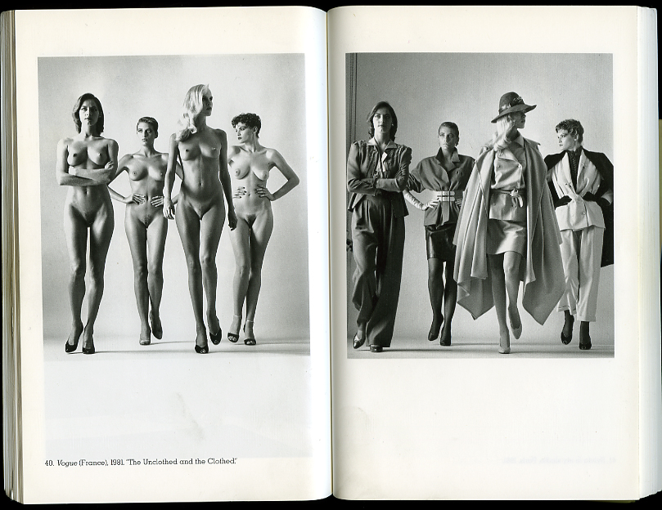

Although many feminists enjoy Newton’s work and believe it communicates their ideal, others disagree and find some of his photography offensive. Critics have deemed Newton ‘Sexist’ and ‘misogynistic’ however he strongly disagrees with these accusations. Newton defended himself against the criticism with the following statement: “why would I spend my life with women, whether they are dressed or undressed, if I didn't like women? Another thing is that in all the photographs, the women are triumphant and the men are just toys. They are just accessories and always servile to the women.” this justification expresses the photographers appreciation of women. Newton’s photograph of Monica Bellucci is reflective of his views; she is sat with good posture, which communicates strength and high status. In addition to this, Bellucci is dressed in tight clothing that flatters her feminine physique whilst showing her cleavage; this is both alluring and daunting to viewers. Supporting this combined theme of strength and sexuality is Newton’s bold colour scheme. Bellucci’s red lipstick symbolises assertion, she is also wearing red boxing gloves, which imply she is ‘triumphant’ in the sport. The use of red is powerful as it connotes danger and sex simultaneously. The black and white costume is also symbolic, white has connotations of purity and black connotes power, with this in mind Newton displays that women can be dominant and remain elegant. This is a message that’s shown naturally throughout Helmut Newton’s photography.

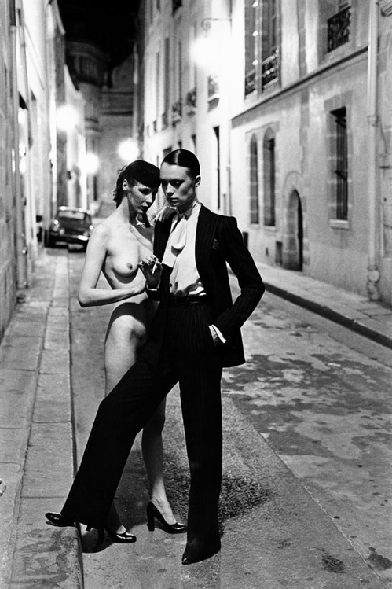
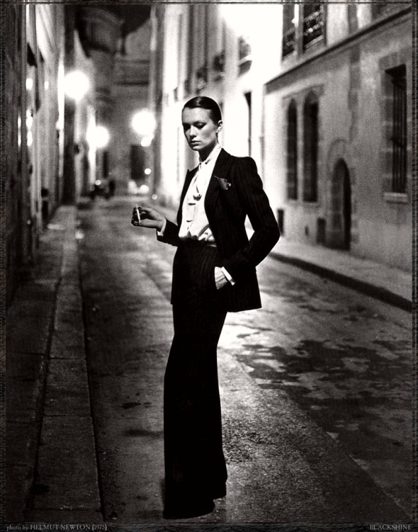
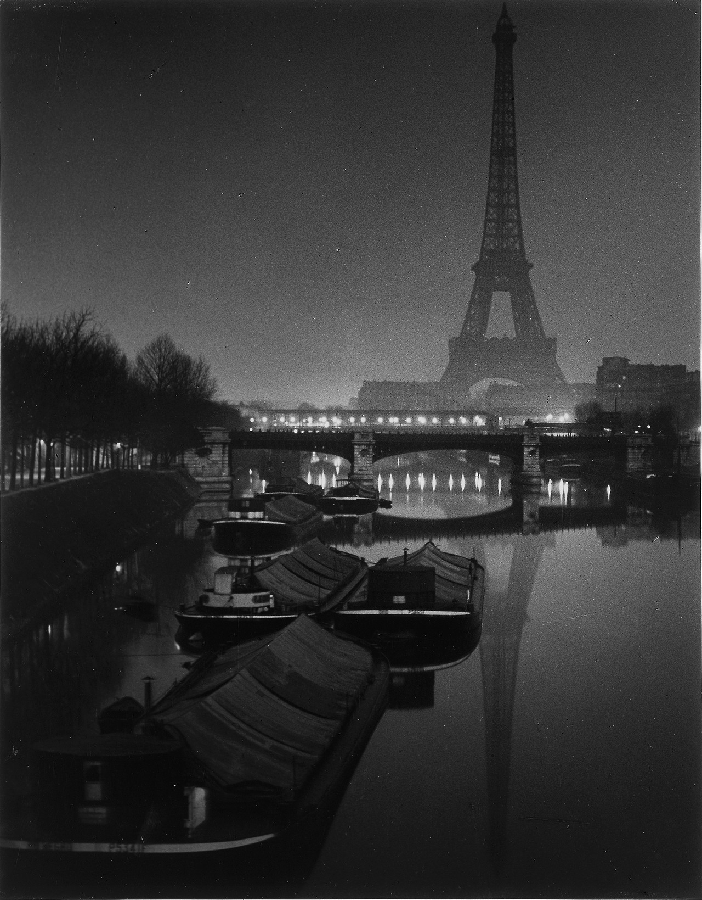
Brassai was a Hungarian-French photographer of the 20th Century; his photography captured the charm of spending the night in Paris. Newton knew Brassai and referred to him as one of the three main photographers who influenced his work. Newton admired Brassai’s photographs of Paris and consequently carried out multiple photoshoots in Paris at nighttime. Newton’s famous shot for French Vogue (1985) uses Paris at night to create a mysterious setting for the androgynous model. Androgyny is another way Newton presents women, showing both feminine and masculine characteristics of the model. This unusual look surprisingly oozes sex appeal whilst showing the similarities between men and women and blurring the lines between genders. The series of photographs from this Vogue shoot featured an Yves Saint Laurent suit jacket, which broadened the model’s shoulders, enhancing the masculinity that Newton had composed. It is also recorded that Newton only used the available street lighting to imitate the works of Brassai, this resulted in heavy shadows and multiple backlights which photographed particularly well in black and white. Lastly, the shoot was in Rue Aubriot and Newton’s house of fourteen years can be seen in the background, which adds a personal element to the photographs.

Brassai composed a book of photographs titled ‘Paris by night’ he felt that "Night does not show things, it suggests them. It disturbs and surprises us with its strangeness." this quote heavily relates to Newton’s photography. Helmut Newton’s photography shocked the public in the way that Brassai feels the night ‘disturbs’ and ‘surprises’ observers with ‘strangeness’. The ‘strangeness’ within Newton’s photography relates to his use of fetish symbolism, which often made viewers uncomfortable and received diverse responses. Fetishism is the use of an object, activity or part of the body as a stimulus to attain sexual gratification. Witty Newton uses objects and composition to symbolise sex, creating absurd and sometimes humorous scenes. Although he shot for conventional magazines and high-end brands his photography doesn’t lose its unique sense of corruption and perversion. It is hard to imagine another photographer that given a Hermes saddle to shoot for Vogue would produce an image like Newton’s ‘Saddle, I’ the original perspective is a product of his open-minded sensuality. What I find most intriguing about ‘Saddle, I’ is the model’s facial expression. Although she in an undoubtedly submissive pose and the saddle highlights her vulnerability, the model’s face is held high and she is staring straight in front of her as though she is confronting somebody. The facial expression subverts her body language, which makes the woman seem threatening and almost like a predator. Helmut Newton cleverly allures and frightens the viewer simultaneously; the concept of fear and sex being connected relates to fetishism and is a continual theme throughout his work.
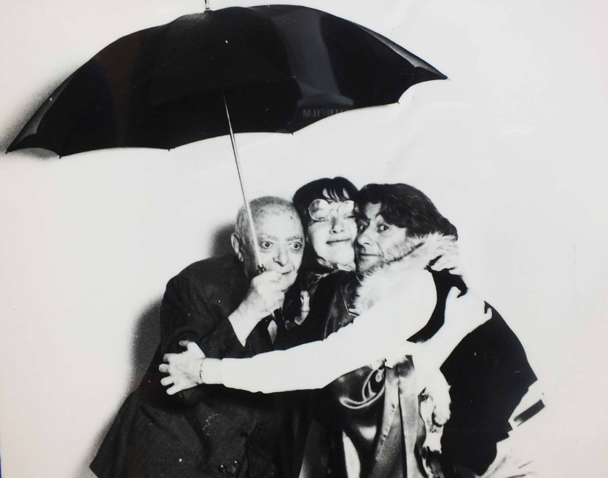

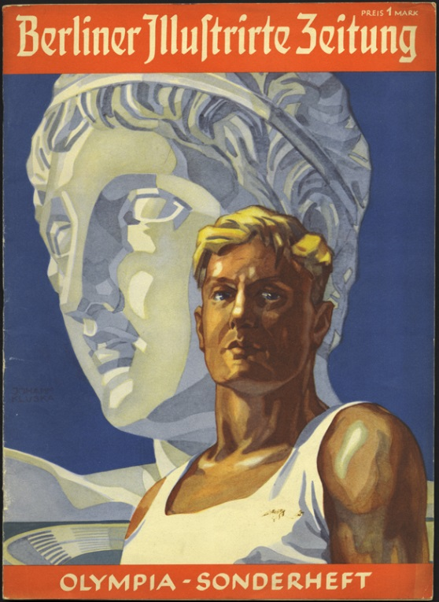
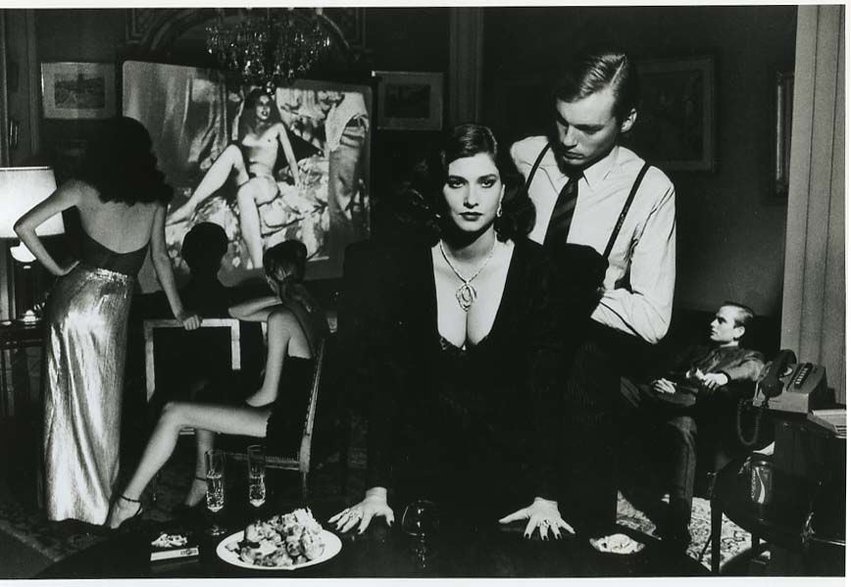
The second of the three main photographers to inspire Helmut Newton was Erich Salomon. Salomon became famous after using an inconspicuous Ermanox camera to take the only photographs of a famous murder trial in 1928. Photography was not permitted in the courtroom however he hid the camera in his bowler hat and the pictures were published in the ‘Berliner Illustrierte Zeitung’, which launched his career. Helmut Newton admitted that he enjoyed paparazzi photographs, as they are candid; he seemed to like the idea of exposing private affairs and documenting reality. ‘In a private apartment, 1980’ coincides with this idea as the shot exposes women and men relaxing together in an apartment watching what seems to be a film of a woman. This photograph is extremely voyeuristic because the viewer is watching the models as they watch another woman. In addition to this there are sexual implications as the still that has been captured of the film shows the woman nude. Newton’s composition enhances the concept of voyeurism as the models are distributed across the room so that the woman is being watched from each angle of the apartment. Furthermore, there is another dimension of voyeurism as the woman on screen is looking towards two more models close to the camera (a man admiring a woman who’s stood confidently with both hands on the table). The models in the foreground relate back to Newton’s use of men as ‘accessories’ because the man’s face is partly covered, as he looks at the woman whilst she looks straight ahead, the centre of attention.
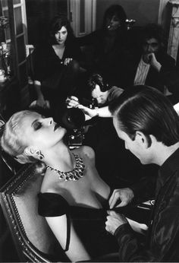
Newton’s use of voyeurism seems to relate to the appreciation of women and also his perspective as a photographer. The photograph ‘Woman being filmed, Paris’ is another explicit example of this, the woman being filmed seems like an object of worship. In this photograph the woman’s purpose is to be gazed upon, perhaps this is why some feminists are dissatisfied with Newton’s photography. The photograph embodies fetishism and voyeurism as the woman being filmed could symbolise a fetish and the models in the background seem to appreciate watching her and the man in the foreground. The composition of this photograph is similar to ‘In a Private Apartment, 1980’ and they evoke the same allusions. In addition these images let the viewer see things from a photographers or paparazzi’s perspective. In order to take complimentary photographs Helmut Newton must thoroughly look at his subjects and models, studying their features and behaviours to capture a flattering still image of them. The paparazzi however have no time to compose or stage their photography so often get up close and personal to achieve shots that document the subject’s activity quickly. Furthermore, paparazzi often take shots unexpectedly to exploit celebrities and criminals. Both aforementioned photographs reflect paparazzi antics as the settings are realistic and the angles are taken as though Helmut Newton has sneakily taken photographs of the oblivious models. The fact that none of the models throughout both images are looking at the camera helps in making the images appear candid.
Some critics claim that Newton is ‘perverted’ due to his representation of women, however I believe his perspectives and ideas may derive from his profession. The women being gazed upon in Newton’s photographs could be symbolic of photographs; they are viewed and critiqued by every observer. Furthermore it is likely that all photographers are naturally inclined to be a voyeur due to their habit of studying what’s around them. Photographers enjoy observing other people and things to the extent that they want to document them, to make them eternal.
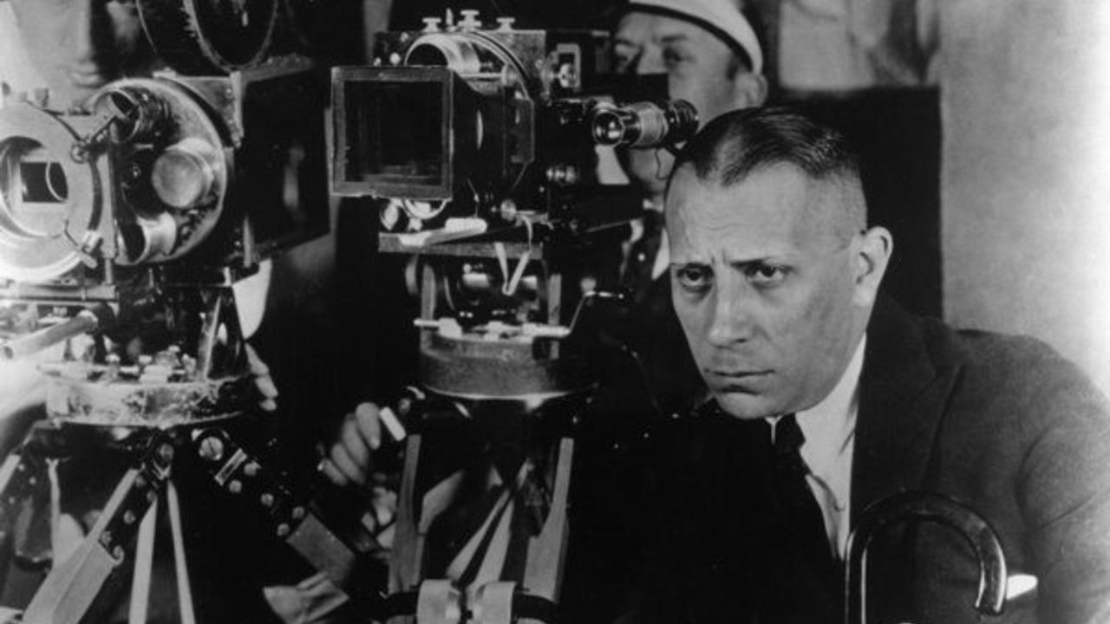
The third and final man that Newton claimed was one of his ‘main’ influences was Erich Von Stroheim, who was an Austrian-American actor, producer and director. Von Stroheim’s work often explored human cruelty, greed and loss of innocence, issues which were prevalent in Newton’s life and his photography. Newton was exposed to human cruelty from a young age as he grew up in Nazi Germany, a racist society that led to him having to separate from his parents, home and country. It may have been the experience of living under violent leadership that conjured some of Newton’s sadistic photographs. The Nazi’s frequently used fear to manipulate people; consequently Newton was introduced to the relationship between violence and power from boyhood (which also relates to ‘loss of innocence’ another popular theme of Erich Von Stroheim). Therefore there is likely to be a correlation between Nazi behaviour and Newton’s use of sadism, Newton may’ve used violent and painful implications to sexually empower women as he’d seen the Nazis empower themselves with violence and pain. However, Newton’s suggestions of sadism are obviously not as extreme and harmful as the horrendous Nazi activity. An example of Newton’s sadist photography is a black and white image of a girl sat on the edge of a bed with a gun in her mouth (1990). The photograph suggests violence however the model is holding the gun herself which shows that she is in control of the situation. There are still many viewers, who do not think it is an acceptable photograph from a fashion photographer. I believe what aggravates many people about the elements of sadism in Newton’s photography is the fact that he is a fashion photographer. The purpose of Newton’s photographs is often to advertise; therefore a majority of his work is available to the general public. Viewers may feel offended that Newton glamourizes sadism and it is easy to see why some people may find his work sexist, as he uses a naked woman who appears to be dead as a ‘fashion statement’. Despite the controversy he caused it is undebatable that Helmut Newton influenced both the fashion and photography industries and society, and continues to today.
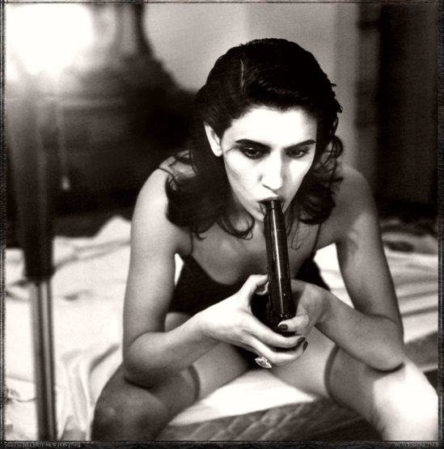

Helmut Newton has had his work exhibited internationally and many artists take inspiration from his diverse photography. After researching the photographer and his work I wanted to see an exhibition of his work for myself. I visited an exhibition in The Foam Gallery, Amsterdam. The exhibition was ‘A Retrospective’ with over 200 photographs ranging from Newton’s early work to his most famous photographs. Seeing the photography on such a large scale was breath taking and as a woman I left the gallery wanting Helmut Newton to take my portrait. He used black and white or overpowering colour palettes to create statement images with powerful messages. Furthermore hard, artificial lighting was frequently used to cast heavy shadows that defined Newton’s models, representing them as strong and chiselled characters. Back lighting was also used in some bedroom shots to illuminate the background and create softer, more romantic shadows. Composition was also a huge part of his photography; each image was staged to create a dramatic yet realistic scene, often with decadent props and exotic settings. Newton took inspiration from other photographers however he produced such original work, exploring taboo themes that many photographers would be uncomfortable focusing on. To conclude, Newton photographed many beautiful women and managed to ensure that each one was presented differently. Regardless of their poses, costumes, locations and props each woman that was the subject of Newton’s photography dominated the photograph in their own style.
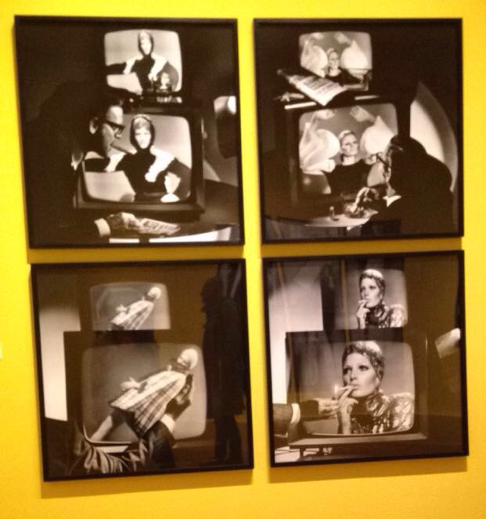

Bibliography
http://www.dazeddigital.com/photography/article/31247/1/your-ultimate-guide-to-helmut-newton
http://www.hamiltonsgallery.com/artists/37-helmut-newton/biography/
http://en.vogue.fr/fashion-pictures/celebrity-photos/diaporama/helmut-newton-and-his-women/11437
https://www.artsy.net/artist/helmut-newton
http://www.queensofvintage.com/weimar-berlins-fashion-photographer-yva/
http://pijet.com/2008/04/20/representation-of-the-female-body-in-newtons-picture/
http://www.grandpalais.fr/en/event/helmut-newton-grand-palais-southeast-gallery
http://alainelkanninterviews.com/helmut-newton/
http://fadedandblurred.com/helmut-newton/
https://www.theguardian.com/lifeandstyle/2001/may/05/weekend.lindsaybaker
http://europe.newsweek.com/helmut-newton-high-fashions-dirty-old-man-133429?rm=eu
https://www.theguardian.com/lifeandstyle/2001/may/05/weekend.lindsaybaker
The Foam Gallery- Helmut Newton ‘A Retrospective’

